**Indexes and Cursors**

1. Consider the **SELL_MANAGE** database which has the following relationship:

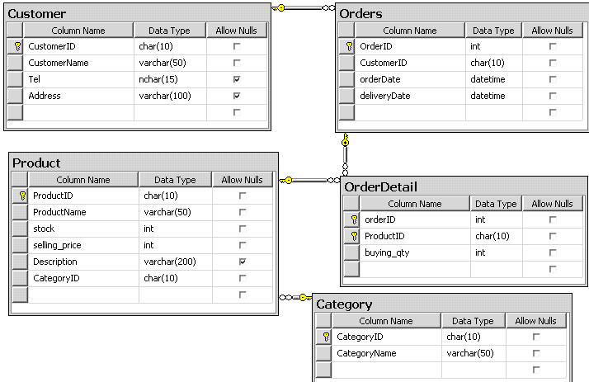

**Indexes:**

1. Write the SQL statements to:
   1. Create a non-clustered index IX_ProName on Productname column of Product table. Ensure that the intermediate and leaf levels of index pages are 25% empty by setting the fill factor value.
   2. Create composite index IX_Cus on address and tel columns of Customer table.
   3. View all the indexes that have been created on Product table using the sp_helpindex.
   4. Create a non-clustered index IX_CategoName on CategoryName column of

Category table, so that while the index is being created, the table and the indexes can be used for queries and data modification.

*Hint: Using with (online=on)*

* 1. Alter and rebuild the index IX_CategoName created on Category table, so that the table and indexes cannot be used for queries and data modification.

*Hint: Using with (online=off)*

* 1. Drop index IX_CategoName on Category table using the drop statement.

**Cursors:**

* 1. Declare cursor named **ProductCusor** including all rows and all columns in the **Product** table.
  2. Open and fetch all rows of **ProductCusor** cursor.
  3. Close and deallocate **ProductCusor** cursor.
  4. Using Northwind database to create a SCROLL cursor named **SuppliersCursor** which contains all suppliers from ‘UK’ and ‘USA’.

Open and display the first and the last rows from cursor.  
Close and deallocate **SuppliersCursor** cursor.